

PAMHoYA PROJECT

Architecture Design Document



August 25, 2025

Version 1.0

TABLE OF CONTENTS Page No.

**1.****Introduction** 1

**2.****Scope** 1

2.1. In Scope 1

2.2. Out of Scope 1

**3.****Frontend Architecture** 2

3.1. View - UI Layer 2

3.2. ViewModel - Logic Layer 3

3.3. Model — API Gateways 3

**4.****Back-end Architecture** 4

4.1. Item harmonisation Service 5

4.2. Data Discovery Service 7

4.3. Data Harmonisation Service (PoC) 9

4.4. Summarisation Service 11

**4.5.****Analytics/Reporting Service** 12

**5.****Conclusion** 13

# **Introduction**

The PAMHoYA platform is designed to make mental health research more discoverable, harmonised, and accessible to a broad range of stakeholders, including researchers, local experts, policymakers, and community practitioners. The system addresses the challenge of fragmented and technical research outputs by providing tools for dataset discovery, item and data harmonisation, plain-language summarisation of research, and role-based dashboards for analytics and reporting.

This document presents the technical design of the PAMHoYA platform. It explains how the system is structured into a frontend web application and a backend composed of multiple microservices each built on a layered architecture. The frontend built using the Model–View–ViewModel (MVVM) pattern, delivers an intuitive and responsive user interface. The backend follows a microservices approach, where each service encapsulates its own business logic and communicates asynchronously through an Event Bus.

The purpose of this document is to provide a clear and structured description of the system’s architecture, focusing on how components interact, how responsibilities are separated, and how the design supports scalability, maintainability, and inclusivity. It serves both as a guide for technical implementation and as a reference for stakeholders to understand the system’s design foundations. This document defines the technical design of the PAMHoYA metadata harmonisation and discovery platform, focusing on microservice-based backend, Model–View–ViewModel (MVVM) frontend, and data workflows for harmonisation and summarisation.

# **Scope**

## In Scope

* Data discovery, item harmonisation, data harmonisation (PoC), research summarisation, and analytics dashboards.
* Frontend web application (React, MVVM).
* Backend services (PostgreSQL, Redis, Event Bus, API Gateways).
* Integration of the Harmony API with a fine-tuned multilingual transformer,
* Integration of LLM/NLP for summaries

## Out of Scope

* Raw data hosting (datasets remain external).
* Mobile apps (future consideration).
* Full data harmonisation

# **Frontend Architecture**

The PAMHoYA frontend is the entry point for all users of the platform. Built as a React web application, it provides the interactive user interface that community stakeholders, researchers, policymakers, and administrators engage with directly. To ensure the application remains maintainable, scalable, and clearly structured, the frontend follows the Model–View–ViewModel (MVVM) design pattern.

In MVVM, the View is responsible for rendering screens and reusable components, the ViewModel manages logic and state for each page, and the Model provides access to backend services through API Gateways. This layered separation means that user interactions (like searches, harmonisation requests, or dashboard navigation) are processed in the ViewModel and translated into calls to backend services via the Model. Results are then passed back to the View for display. The frontend architecture is shown in Figure 1.

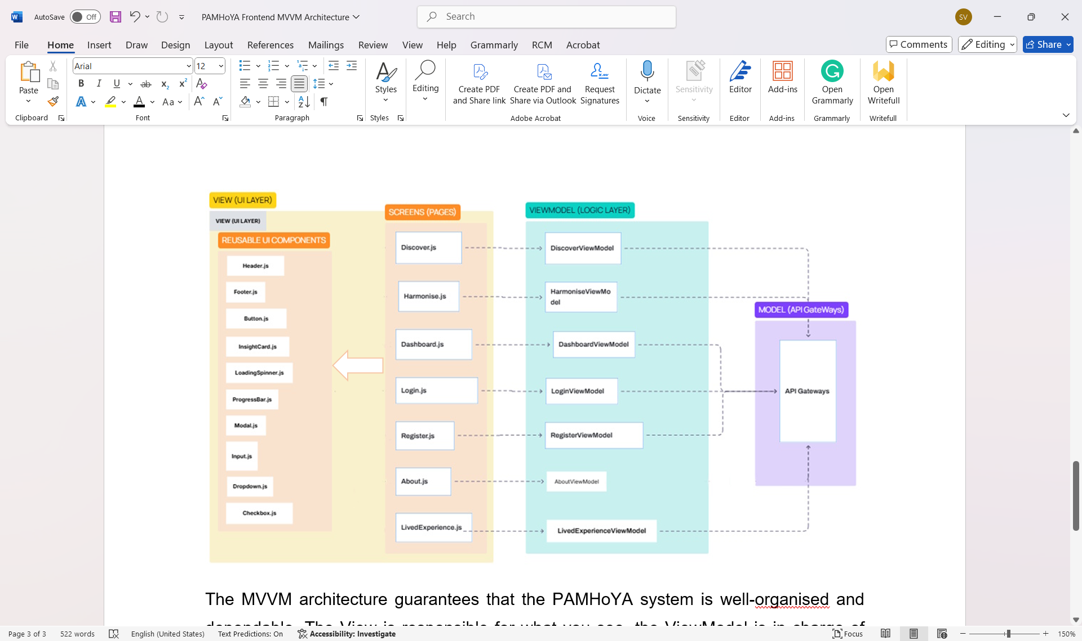

Figure 1: Front-end Architecture

## View - UI Layer

The View contains pages and reusable components. It renders data and forwards user events to the ViewModel; it does not implement business logic.

* Screens (pages): Login.js, Register.js, Dashboard.js, Discover.js, Harmonise.js, About.js, LivedExperience.js.
* Reusable components: Header.js, Footer.js, Button.js, Modal.js, Input.js, Dropdown.js, Checkbox.js, LoadingSpinner.js, ProgressBar.js, InsightCard.js.
* Role: Present data, handle layout/accessibility, trigger ViewModel actions (e.g., “Search”, “Harmonise”, “Generate Report”).

## ViewModel - Logic Layer

The ViewModel is the stateful controller for a screen. It interprets user intents, manages local/UI state, orchestrates side-effects, and decides what the View should render.

* Responsibilities: input validation, calling the Model, caching/pagination, loading/error states, and role-aware presentation decisions.
* Examples:
  + LoginViewModel handles login, tokens, and error messages.
  + DashboardViewModel selects the correct dashboard view (researcher, LE expert, policymaker, admin) and fetches KPIs/maps.
  + DiscoverViewModel manages search queries, filters, and results paging.
  + HarmoniseViewModel coordinates item/data harmonisation flows and job status polling.
* Contract with the View: exposes simple, render-ready state (e.g., isLoading, error, items, onSubmit()), so the View stays logic-free.

## Model — API Gateways

The Model isolates all data access behind typed clients that speak to backend API Gateways; it never talks to the View directly. ViewModels call the Model (e.g., discovery.search(), harmonise.alignItems()), which routes requests via the appropriate API Gateway to backend microservices (Authentication, Data Discovery, Item/Data Harmonisation, Summarisation, Analytics). The API gateways serve as secure entry points shielding the frontend from backend topology and letting services evolve independently.

By organising the frontend in this way, PAMHoYA keeps visual presentation, business logic, and data access cleanly separated, mirroring the same layered discipline used in the backend microservices. This also provides a natural bridge into the backend architecture, which extends these principles to distributed services and asynchronous communication across the platform.

# **Back-end Architecture**

The backend of the platform is built on a microservices architecture, where each service is designed to handle a distinct responsibility, such as item harmonisation, data discovery, research summarisation, data harmonisation, and analytics/reporting. These microservices are hosted within Docker containers and are accessed through dedicated API Gateways that route requests from the frontend React web application to the appropriate service. Authentication services provide secure access control across the stack.

To enable scalability and loose coupling, the microservices communicate asynchronously through an Event Bus, allowing them to exchange updates and trigger workflows without creating direct dependencies. This design ensures that each service can operate independently while still contributing to a coordinated system. For example, harmonisation results or new datasets discovered can trigger downstream updates in reporting or summarisation services.



Figure 2: Back-end Architecture

Each of the microservices shown in the backend architecture builds on a common layered design, ensuring consistency while allowing for service-specific logic. Requests flow from the application frontend through the appropriate API Gateway into the API Layer of a microservice, which exposes endpoints tailored to that service. Behind the API Layer, each microservice contains its own Business Logic to handle specialised functions—whether harmonising items, discovering datasets, generating summaries, harmonising raw data, or producing analytics dashboards. These are supported by a Data Access Layer that manages persistence, with PostgreSQL serving as the primary datastore across the system. The following subsections describe the internal layered architecture of each microservice in detail, highlighting how its unique logic is implemented within this consistent design pattern**.**

## Item harmonisation Service

The Item Harmonisation Service enables researchers to align and compare items—such as survey questions or variables—across instruments and datasets. It leverages the Harmony API with a custom multilingual transformer to provide semantic matching.



Figure 3: Item harmonisation Service

After requests are received through the API Layer, the Item Harmonisation Service follows a structured workflow to ensure both efficiency and flexibility, depending on how the user wants to harmonise items.

The service first checks the Redis cache to determine whether the request has been processed recently. If cached results exist—such as embeddings or similarity scores—they are returned immediately, avoiding unnecessary recomputation and reducing calls to the Harmony API. If the results are not cached, the workflow diverges depending on the type of harmonisation request being made:

* **New vs New items**: A user may submit two new items that are not part of the stored catalogue. In this case, the service checks Redis and, if needed, calls the Harmony API directly to generate embeddings and compute similarity scores using the custom multilingual transformer model.
* **Stored vs Stored items**: A user may select two items that already exist in PostgreSQL’s library of standard reference items. Here, the service retrieves the items from the database and either serves previously stored harmonisation results or calls the Harmony API if the match has not yet been computed.
* **New vs Stored item**: A common scenario is for a user to introduce a new item and harmonise it against a selected stored reference item from PostgreSQL. In this case, the new item is normalised and passed to the Harmony API, while the reference item comes from the PostgreSQL database. The results are then returned to the user, saved in PostgreSQL for future reuse, and cached in Redis for faster access.

Regardless of which path is taken, once the Harmony API produces similarity scores, the results are returned to the front-end and displayed to the user. At the same time, harmonisation results are written into PostgreSQL for long-term reference—capturing alignments, job logs, and audit trails—and saved into Redis to support faster future lookups.

## Data Discovery Service

The Data Discovery Service is a microservice that provides a catalogue of datasets by storing and managing their metadata. It does not host the raw datasets themselves, instead, it helps researchers and systems discover what data exists, how datasets relate to one another, and how they can be accessed.



Figure 3: Data Discovery Service

The Data Discover service has five core functions:

* Search: Enables keyword and filter-based discovery of datasets.
* Curation: Supports submission of new dataset metadata by researchers, with curator approval before inclusion.
* Deduplication: Detects and removes duplicate records from multiple sources.
* Link Check: Validates external dataset URLs to maintain catalogue quality. This ensures that links to open-source downloadable datasets from platforms like SAPRIN or NIDS are valid.
* Request Access: For restricted datasets, allows users to send an access request (with contact details and conditions) directly through the service.

The Data Access Layer provides a clean interface between business rules and the database, using repositories and an ORM to read and write metadata efficiently and securely. At its core, the PostgreSQL database serves as the single source of truth for all metadata, storing dataset descriptions, fields, links, access conditions, submissions, relationships, and access requests. It is extended with advanced search and spatial capabilities, including fuzzy text search and semantic similarity. For external data access, the service supports two modes: direct access, where open datasets are linked to files, APIs, or portals, and request-based access, which includes restricted datasets that provide custodian contact details, access conditions, and a built-in email workflow that enables researchers to request data directly through the service.

## Data Harmonisation Service (PoC)

The Data Harmonisation Service is a proof-of-concept microservice that aligns and merges two datasets into a consistent, standardised structure. It ensures schema compatibility, normalises values, and produces a harmonised dataset along with a clear report of the transformations applied.



Figure 4: Data Harmonisation Service

After client requests are routed through the API Gateway, the service validates and loads the two datasets into its harmonisation pipeline. Within the business logic, it performs schema analysis to detect column differences, applies mapping rules to align fields, normalises values and units, and merges the datasets into a unified standard schema. Each step is logged, and a report is generated detailing the mappings, conversions, and any warnings. The Object–Relational Mapper (ORM) layer then persists metadata and results into PostgreSQL, providing a durable record of harmonisation jobs. The outcome is both a harmonised dataset, ready for further use, and a transparent audit trail that shows exactly how the data was transformed.

## Summarisation Service

The Summarisation Service generates plain-language summaries of research studies to make academic findings more accessible to non-technical stakeholders. It combines automated NLP summarisation with human review to ensure outputs are accurate, community-friendly, and reusable.



Figure 5: Summarisation Service

Requests enter the service through the API Layer, which exposes endpoints for generating new summaries and retrieving existing ones. The Deduplication Checks component ensures that if a summary for the same study (or set of studies) already exists, it is reused rather than regenerated. Where no prior version exists, the Draft Summary (Automated) component calls a self-hosted NLP/LLM model to produce an initial plain-language draft that captures the study’s purpose, sample, indicators, and findings. Drafts are then routed to the Manual Evaluation & Approval stage, where human reviewers can edit, refine, and approve them before publication. All summaries, along with their versions, audit logs, and metadata, are stored through the Object–Relational Mapper (ORM) and Repositories, which manage persistence in PostgreSQL.

## **Analytics/Reporting Service**

The Analytics/Reporting Service delivers role-based dashboards that translate harmonised metadata, study indicators, and system activity into meaningful insights for different stakeholder groups. It supports researchers, local experts, policymakers, and administrators by providing tailored analytics and visual summaries that highlight trends, patterns, and platform usage statistics.



Figure 6: Analytics/Reporting Service

Requests flow through the API Layer, which routes users to the appropriate role-based dashboard. The Stakeholder Dashboards present customised views: researchers see harmonisation matrices and provenance tracking, local experts see topic or population-level summaries and trends, policymakers see interactive maps and evidence coverage, and administrators view system usage and health metrics. These dashboards are powered by the Analytics Engine, which runs aggregations, statistical queries, and any relevant analysis. The Data Access Layer connects to PostgreSQL, where harmonised metadata, instruments, study indicators, and usage logs are stored. To optimise performance, the service also uses materialised views for precomputed summaries and faster dashboard rendering. Together, this layered design ensures that complex harmonisation data is distilled into clear, actionable insights for all stakeholder groups.

# **Conclusion**

The PAMHoYA platform is built on a layered, modular architecture that separates concerns between the frontend and backend while maintaining a consistent design philosophy. The frontend applies the MVVM pattern to keep user interaction, logic, and data access clearly defined, while the backend leverages microservices with unique business logic, PostgreSQL persistence, and asynchronous communication through the Event Bus. Together, these design choices ensure the system is scalable, maintainable, and adaptable to evolving research needs.

By combining discovery, harmonisation, summarisation, and reporting, the platform lowers barriers to accessing mental health research and provides tailored insights for researchers, community stakeholders, policymakers, and administrators. This technical design provides a strong foundation for implementation, testing, and future extension of the PAMHoYA system.